Application Engineering and Development

ISY G100

Exam I

9/28/2012

Exam Time: One Hour

Closed Book

Professor

Kal Bugrara &

Our Teaching Assistants

Consider the model below and the vital signs table

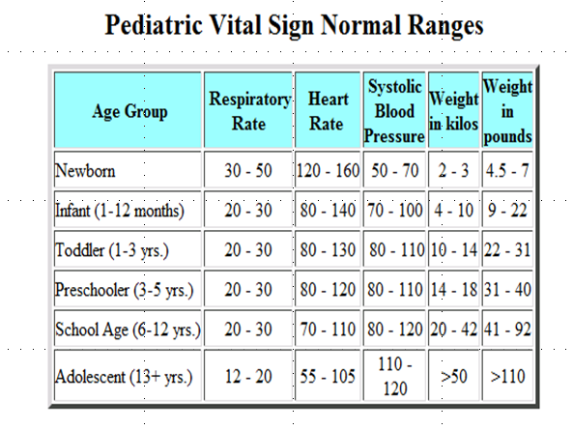

1. For the model defined above, show where would you place the following methods and attributes?
2. social security number
3. home address
4. patient id
5. billing address
6. Date of birth
7. The last visit to the doctor
8. insurance info (company name, employer name, insurance coverage type, etc)
9. heart rate
10. weight as of a given visit to the doctor’s office
11. current date (think of where you need the current or today’s date).
12. Calculate age (assuming there is a function to perform the calculation based on DOB and today’s (or current) date. Date will be represented as an int and the unit of measure will be interpreted as milliseconds. The return value of the calculate function will be an int as well. [Later you will use the following syntax to do the calculation [**Calculator**.CalculateAge(DOB dob, current date);]
13. getPersonAgeGroup, calculate a person’s age and returns a string representing the age group of the person as described in the table above.
14. Get the number of patients of a certain age group. This function takes the age group as a string and returns the number of patients in that age group. This method will use another class to determine the patient age.
15. Find all persons with abnormal respiratory rate. Explain all other methods you need to make this search method work.

[Questions 2 through 7] Given the information presented in question 1, the patient model, as well as the normal ranges table, define complete java classes for each of the following classes. Please include information that is relevant to the requirements described above (attributes, get, set, and calculation methods).

1. **Person Class**
2. **Vital Signs Class**
3. **Patient Class**
4. **Person Directory**
5. **Patient Directory Class**
6. **Calculator Class**

See question 1K. Normal ranges rules can go here as well